Preliminary Design Report
EGR 313 - Fall 2025
V Venom
Team 5
Majed Alharbi, Mason Benvenuto, Ethan Diedricks, Varun D Nair
Ira A. Fulton Schools of Engineering, Arizona State University

Abstract: This report documents the complete engineering development of the V Venom wrist-mounted web-shooter system, designed and fabricated as part of the EGR 313 course objective to integrate theoretical engineering principles with practical design and prototyping. The project applies the conservation of mass and energy, as expressed through fluid dynamics and Bernoulli’s equation, to create a pressurized CO₂-driven mechanism capable of safely dispensing a polymer-based web mixture. The report traces the process from initial conceptual sketches through CAD modeling, material selection, subsystem design, and mechanical integration. Fabrication employed additive manufacturing and precision machining to construct a reinforced housing, fluid reservoir, and nozzle-trigger assembly. Experimental validation assessed range, pressure performance, and adhesion strength, with results demonstrating consistent operation and a maximum spray distance of approximately four meters. Analytical comparisons between theoretical flow predictions and measured data confirmed the effectiveness of the design while identifying minor losses due to nozzle geometry and fluid viscosity. Challenges related to sealing, structural reinforcement, and material brittleness were addressed through iterative redesign and testing. Overall, the report presents a comprehensive account of the design evolution, experimental outcomes, and engineering analysis that collectively demonstrate successful realization of a safe, functional, and reusable web-shooter prototype consistent with the learning objectives of EGR 313.

NOMENCLATURE
F = Force m = Mass
g = Gravitational acceleration = 9.81 m/s² V_{out} - Exit velocity of the fluid (m/s)
h = Elevation P_{in} - Inlet Pressure
P_{out} - Downstream or Exit pressure $ρ$ - Fluid density (kg/m³)

- Introduction
The EGR 313 course emphasizes the practical application of fundamental engineering principles—specifically, the conservation of mass, momentum, and energy through the design, fabrication, and validation of a functional prototype. Within this framework, the V Venom project focused on the conception and realization of a wrist-mounted web-shooting device inspired by the fictional technology of Spiderman. The objective was to translate a popular imaginative concept into a safe, mechanically reliable system that demonstrates the integration of fluid mechanics, materials engineering, and mechanical design. [1]
The final prototype represents a compact, refillable, and reusable web-deployment mechanism capable of projecting a polymer-based fluid stream up to approximately four meters. The device incorporates three coordinated subsystems: (1) a pressurized canister that holds the web fluid at a pressurized state; (2) an enclosed housing to securely hold the canister to the bracelet; and (3) a nozzle–trigger assembly that opens and closes the valve in the canister to regulate flow and exit velocity. The design process applied Bernoulli’s equation to model pressure–velocity relationships and optimize nozzle geometry for maximum range and safety.
The project objectives were as follows:
- To design and construct a functional wrist-mounted web-launching mechanism integrating a pressure system and polymer fluid reservoir.
- To develop and characterize a synthetic web mixture with appropriate viscosity, adhesion, and tensile strength.
- To implement a mechanically reliable trigger system ensuring controlled fluid discharge.
- To ensure safe operation through material selection, wall reinforcement, and effective pressure management.
- To evaluate system performance through experimental testing, including measurements of shot distance, adhesive behavior, trigger response, and reload efficiency.
Development progressed through structured design phases: conceptual sketching, CAD modeling, component sourcing, fabrication using 3D printing and machining, and iterative performance testing. Data collected from pressure and range experiments were analyzed to compare theoretical predictions with measured results, validating the influence of nozzle geometry and operating pressure on fluid exit velocity.
This report presents a comprehensive record of the V Venom project, documenting the design rationale, engineering analyses, fabrication procedures, experimental results, and conclusions. The work demonstrates how fundamental engineering laws can be applied to design a creative yet technically robust prototype embodying the overarching goal of EGR 313 to bridge theoretical understanding with practical engineering innovation.
- Project Description
2a. System Overview
The web shooter consisted of three primary subsystems:
- Pressurized Fluid System - canister that was used to hold the web fluid along with allowing it to be pressurized for flow.
- Canister Housing - a simplified design to securely hold the canister and allow for smooth axial motion to open the valve.
- Nozzle and trigger Mechanism - translated vertical motion to axial motion to allow the canister to release the pressurized web fluid.
Pressurized web fluid inside a canister, where its static pressure was converted to exit velocity following Bernoulli’s principle. The web fluid was forced through a narrow nozzle, forming a high speed jet capable of reaching the prescribed 4 meter target ranged
2b. Operating Principle
The V Venom web shooter operates by converting stored fluid pressure into kinetic energy at the nozzle exit , allowing the web fluid to be projected over a controlled distance. The system relies on a pressurized canister containing a polymer based fluid mixture. Upon actuation of the trigger mechanism, the internal valve opens momentarily, allowing the pressurized fluid to accelerate through a converging nozzle.
The behavior of the system is primarily described by Bernoulli’s equation, which relates energy within the canister to the exit velocity of the fluid jet. Under the assumption of incompressible flow and negligible elevation change, the majority of the stored pressure energy is converted into kinetic energy at the nozzle.
Minor energy losses due to viscous effects and internal friction were anticipated and accounted for through conservative design margins. Despite these losses, the system was designed to achieve the target range of four meters while maintaining stable formation and controlled dispersion. [2]
2c. Design Constraints and Requirements
Key design requirements included:
- Compact form factor: suitable - for wrist mounted operation
- Safe pressure containment - under repeated use
- Repeatable triggering - mechanism
- Lightweight construction - to minimize user fatigue
- Ease of fabrication - using available manufacturing resources
Pressure limits were selected to remain within the structural capabilities of 3D printed PLA while still providing sufficient exit velocity.
- Detailed Design
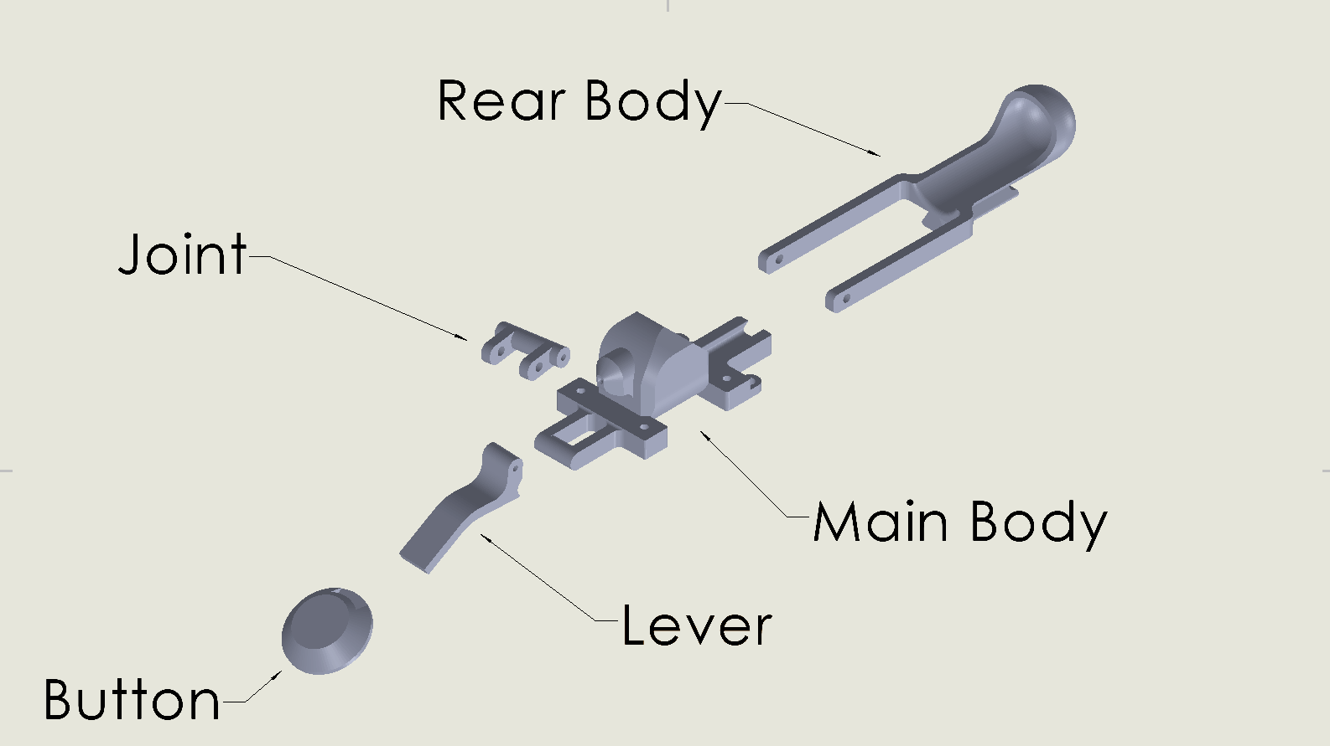
3a. Mechanical Body Design
The main body served as the central structural frame securing the canister, nozzle, and trigger components. The housing was designed to:
- Maintain alignment of all subsystems
- Translate normal force into axial force
- Interface securely with a wrist mounted guard
- Permit rapid removal and replacement of the cartridge
The entire design focus was around making a product that was reliable along with a focus for ease of manufacturability.

Material Selection
PLA was selected for fabrication due to:
- Resistance to cracking under pressure
- Improved heat tolerance during repeated discharge
- Strong layer adhesion in 3D printed components
Wall Thickness and Tolerances
- Wall thickness: 4-5 mm around pressurized regions
- Nozzle seat tolerance +/- 0.10 mm for precise sealing
- Trigger mount tolerance +/- 0.25 mm to ensure mechanical fit
These valves ensured structural integrity while keeping the device lightweight.

3b. Subsystem Designs
Pressure Subsystem
The refillable canister provided a housing for web fluid to be pressurized for delivery. The prefabricated valve, along with the o-ring provided a near perfect seal for the nozzle to perform similarly to theoretical analysis.

Fluid Reservoir
The reservoir stored a polymer mixture consisting of:
- Isopropyl Alcohol
- Polysorbate 80
- R-134a for pressurization
- PMMA powder
The fluid's viscosity allowed it to maintain cohesion during launch, forming a narrow stable jet.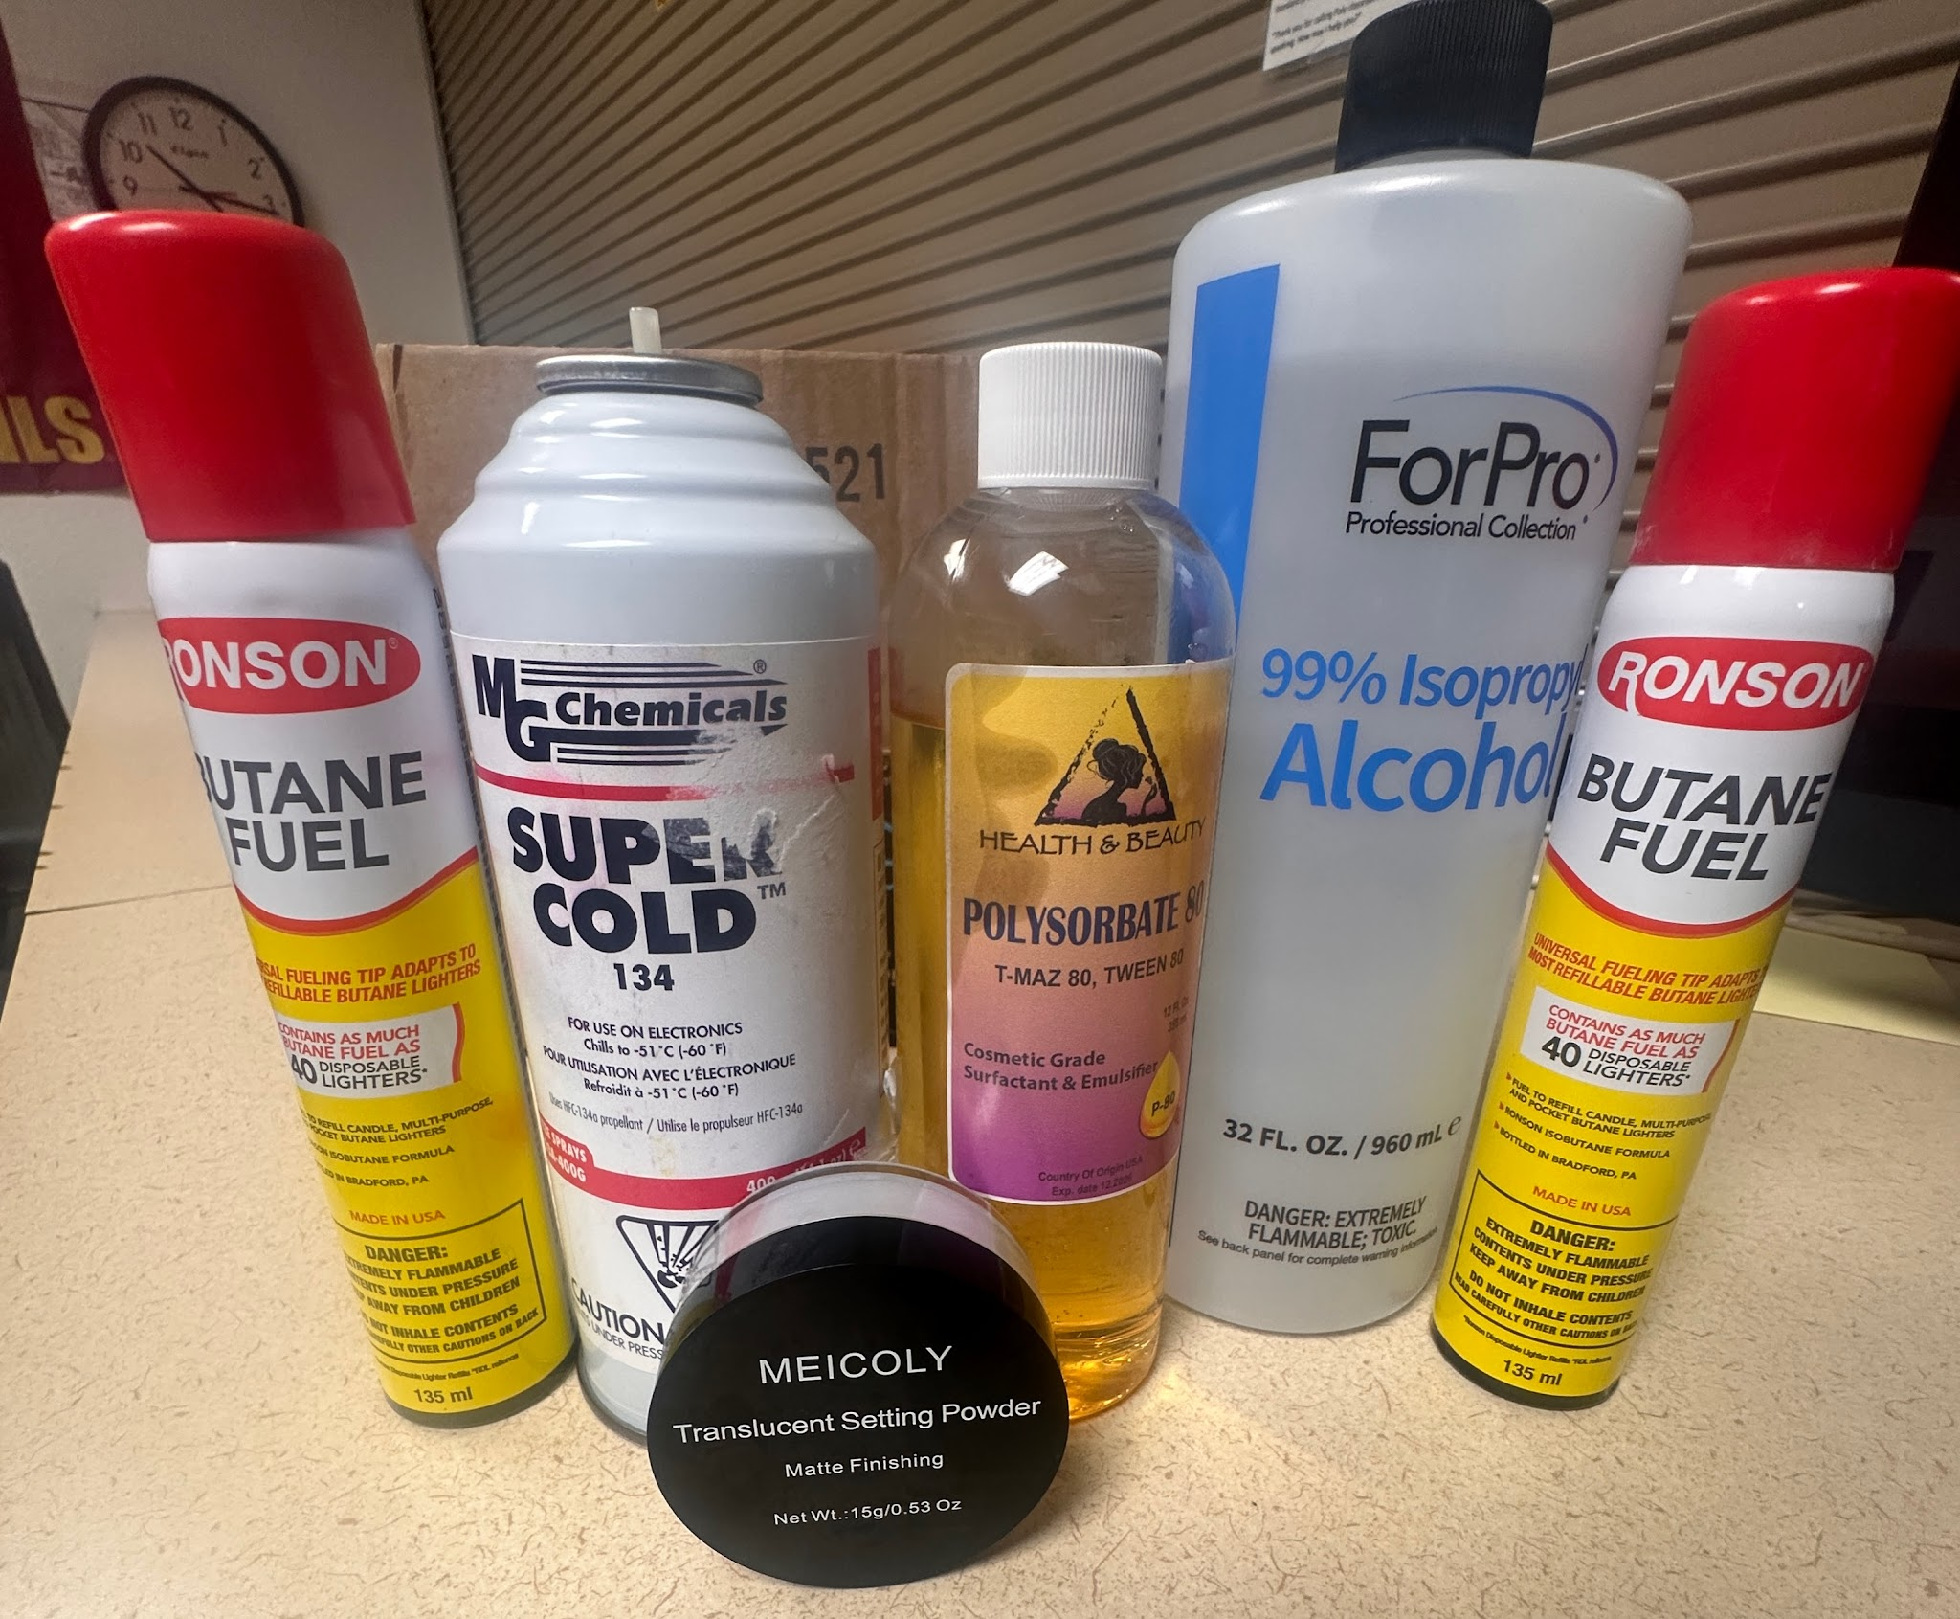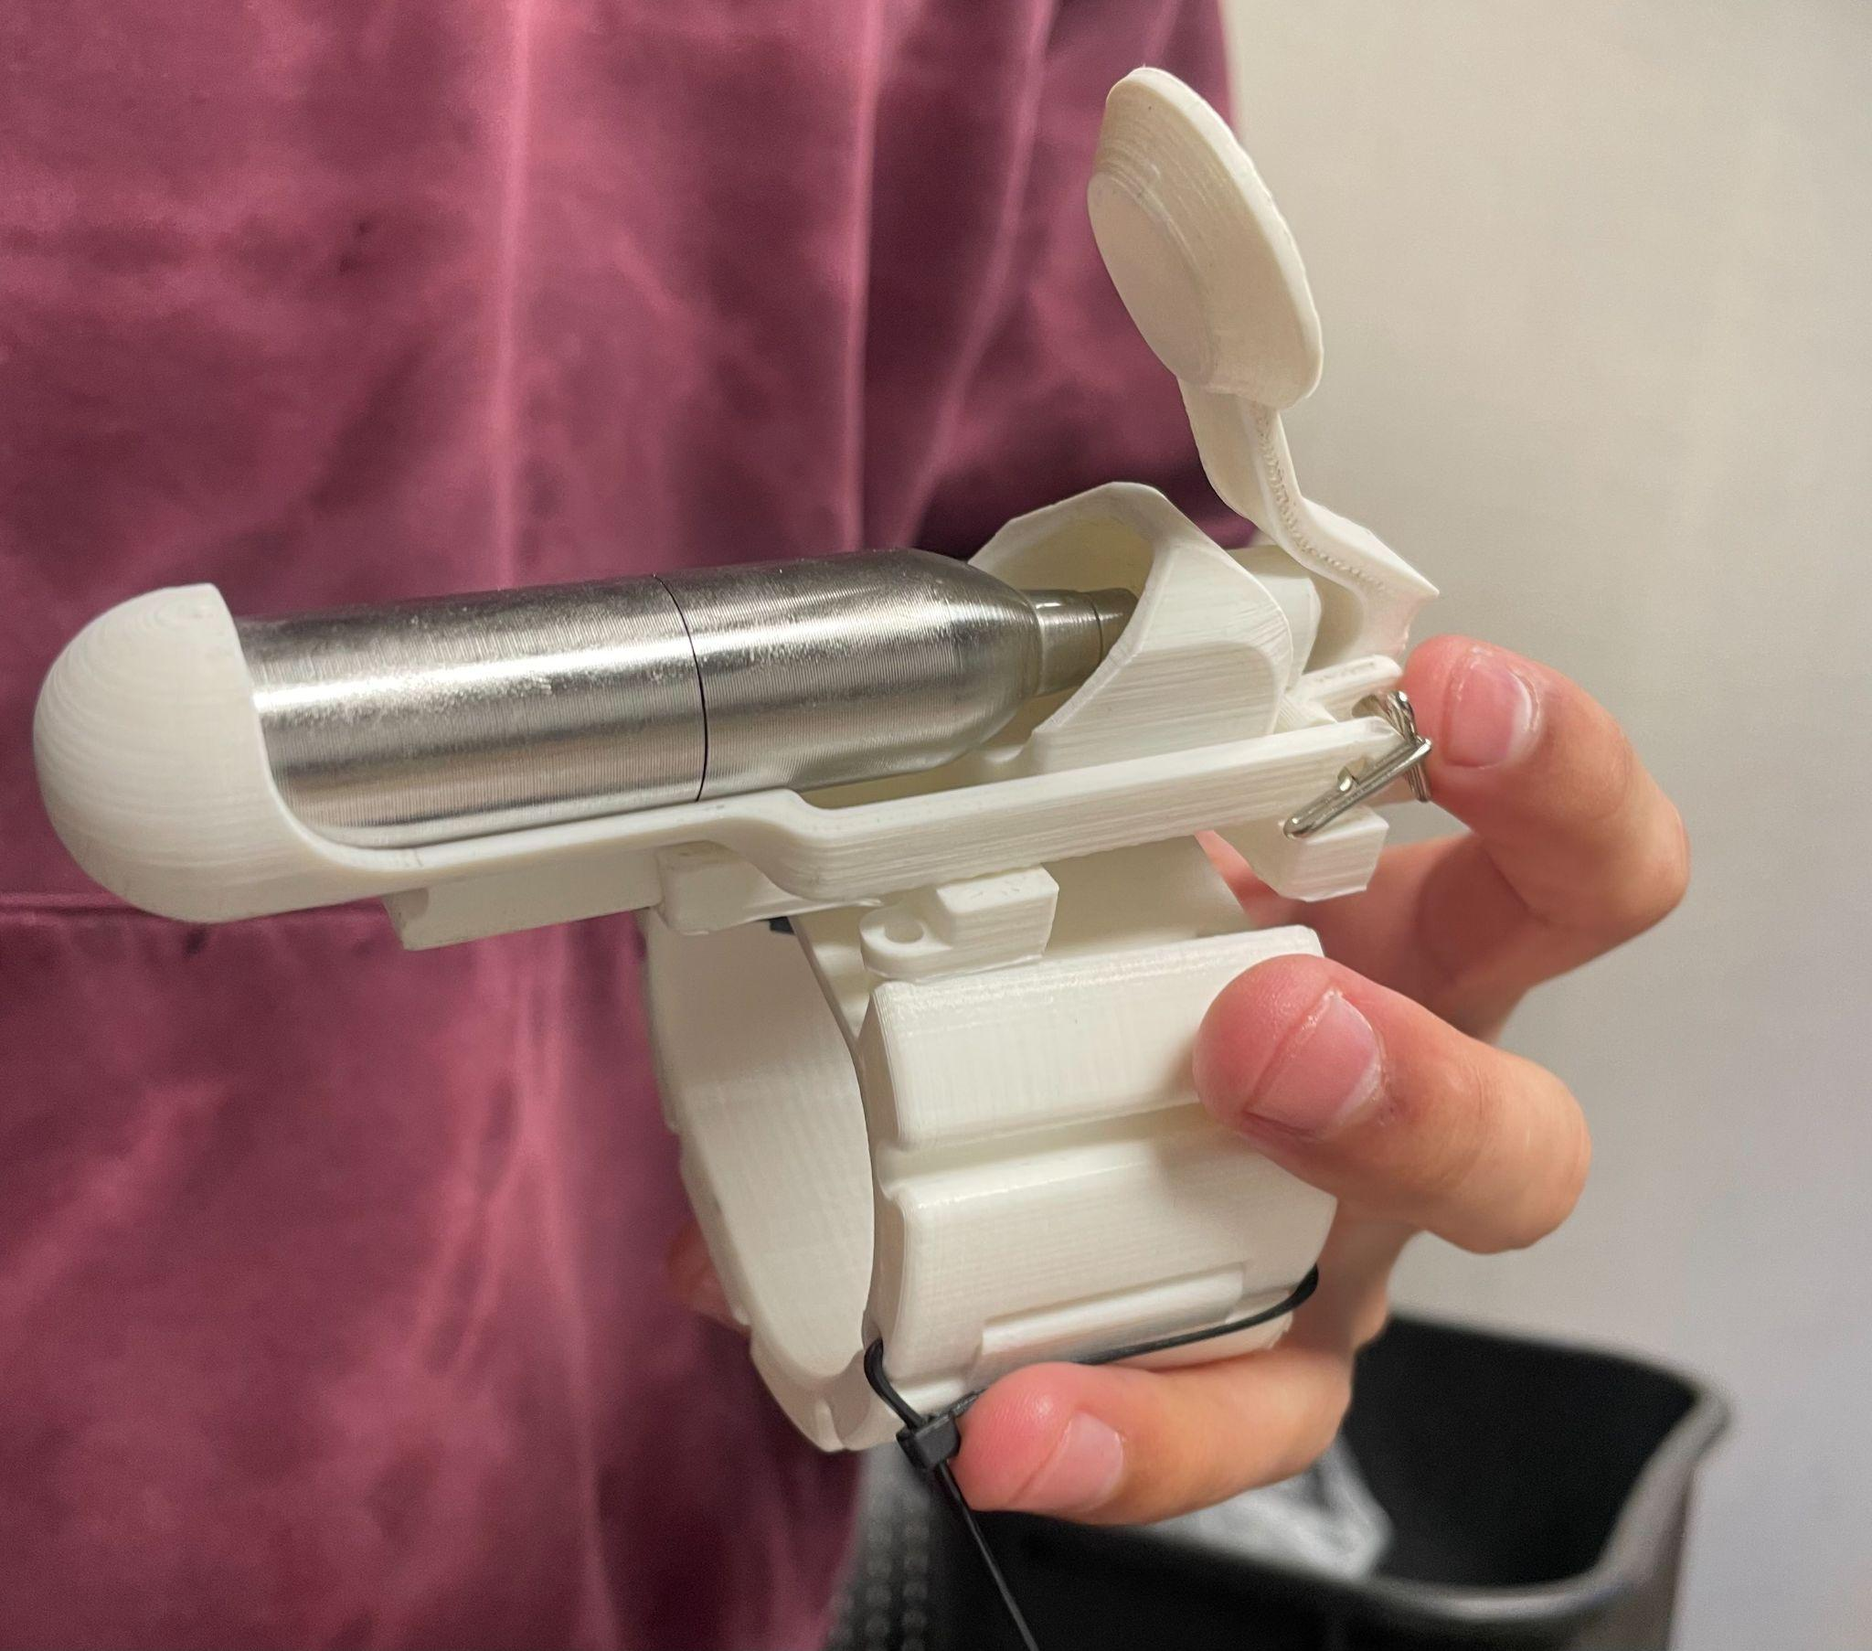

Trigger Mechanism
The mechanical push activated trigger, pushed the canister forward opening the valve.
The wrist mounted placement ensured balanced operation and consistent user activation.

- Testing and Validation
4a. Experimental Setup
Testing was originally set to be conducted at the designated field south of the red lot at Arizona State University, but it ended up being performed indoors in a stable, wind free environment inside of the innovation hub also located at Arizona State University. Five total trials were conducted. For each test, the following performance metrics were recorded:
- Shot distance (Primary metric)
- Trigger responsiveness
- Fluid Consistency and adhesion
- Accuracy of trajectory
- Reliability of sealing and pressure retention
Testing equipment included
- Tape measure (5 m range)
- Refillable cartridges
- Premixed web fluid
- Notebook for data collection
4b. Validation Method Using Bernoulli’s Equation
To Validate the performance of the Web Shooter, Bernoulli’s equation was applied to analyze the pressure velocity relationship with the pressurized nozzle system. By assuming incompressible flow and negligible elevation change, Bernoulli’s principle relates the static pressure within the pressurized canister to the dynamic pressure and velocity of the exiting fluid through the nozzle

P_{in} + ½ pV_{in}² = P_{out} + ½ pV_{out}2 [3]

This relationship validates that in case an internal pressure directly increases the kinetic energy of the existing fluid, resulting in higher launch velocity and range. Experimental testing of shot distance and fluid deployment confirmed this theoretical prediction, as higher canister pressures produced consistent increases in exit speed and projectile distance. Therefore, Bernoulli's base analysis effectively supports the operational design and expected performance of the system.

- Results and Discussion
5a. Experimental Results
Experimental testing of the Web shooter demonstrated consistent and repeatable system performance across all five trials. The primary performance metric (shot distance) closely matched the design target of 4.0 meters, with measured distances ranging between 3.9 m and 4.1 m. The average shot distance of 4.0 m confirmed that the system reliably met its intended operational requirement.

In addition to range performance, qualitative observations indicated stable jet formation during discharge, minimal lateral deviation, and consistent trigger response. No instances of leakage, structural deformation, or valve malfunction were observed during testing. The sealing system maintained pressure integrity throughout repeated firings, showing effective material selection and tolerance control.

Agreement with Theory
Bernoulli- based velocity estimates matched closely with measured performance:
- Higher reservoir pressure produced longer range shots
- No energy losses beyond expected minor viscous and frictional effects
- The nozzle geometry successfully maintained a narrow fluid stream

- Conclusion
The wrist mounted web shooter successfully met all project objectives established at the beginning of the semester. The final prototype effectively integrated principles of fluid mechanics, materials science, and mechanical design into a wearable system capable of launching a synthetic web fluid to a target distance. Analytical predictions based on Bernoulli’s equation were validated through experimental testing. As measured shot distances closely matched theoretical expectations. The PLA 3D printed housing provided subsystems structural integrity to withstand repeated pressure without leakage. All subsystems, including the pressure delivery system

- Appendix
Table 1: Bill of Materials
Qty | Item # or Quote # | Direct Website Link to Product | General Description of Item | Business Purpose/Benefit for the Purchase | Unit Price | Line Total
1 | UL00091 | https://www.ultraforceairsoft.com/product-page/ultraforce-12g-refillable-cartridge | refillable co2 canister | Gas Delivery mechanism for our web fluid | $15.00 | $15.00
1 | B01LYNUFSX | https://www.amazon.com/iit-91000-Butane-Pencil-Torch/dp/B01LYNUFSX/ref=sr_1_58?crid=2JQGXOM7RDG1Q&dib=eyJ2IjoiMSJ9.k-QkYwjVouiZXAAgjHT8qldXTSQcQWGuf6uc8AfJyNswpZjC3vgcCqoLnrw3xegPyEJ7fQS_64IhM51L07VogPyqHIa6USb_IibnJRn0arIi5mCaJnPuBMUd88bct3WksxAvg1EjwojvXZxv2EVuKq-CLKnmx9Li3q-azrRnQtrwqfRlJJ9LEluSoQHKvuBq1wUmTAd_vzRPBXXv4zkRZ6-9Auqk2-dzwFqR4UKpD91HWPWeL-UJ2dYrPx-_UKrCsTVzlnbxLEBeX09imSHydsFYKgAJe-TokgzA_2g4Gio.tnSiYJ9xjtxeJv5qB1ZanDUquV4ut-lasOyeCGAHx18&dib_tag=se&keywords=butane+pen&qid=1758058719&sprefix=butane+pen%2Caps%2C195&sr=8-58 | Butane Torch | Gas Delivery mechanism for our web fluid (second test) | $9.49 | $9.49
1 | B0DVSS196D | https://a.co/d/3Lvr5nR | Acetone pure | for making wep fluid | 5.98$ | 5.98$
1 | B086Q6QFQS | https://a.co/d/id34Acd | Ethanol | for making wep fluid | 16.59$ | 16.59$
1 | B0DP79TTM4 | https://a.co/d/agGPA03 | Polyvinyl Acetate | for making wep fluid | 8.49$ | 8.49$
1 | B071KXLG65 | https://www.amazon.com/Mia-Secret-Acrylic-Powder-Professional/dp/B071KXLG65/ref=sr_1_3?crid=376WQZ8ZBHXYG&dib=eyJ2IjoiMSJ9.nobrQqI8jmXE-kc_VC14RNE0_Q8L-bLGbzLvUxfMp1DtIMYMLZscKQWn9u4teAC5jE0Pg805CAxaFHDVuMHrVPGqVnrnc1-P65rWRHo_9hJ7z1Wd4pshbojl_I9dJOM9HXeXk397o66HpXeXgIceAuRQZiGcShbBraNbVE2irIOhulol-MZmACpmUruBFeBH3GEYrXWuPyugtxcN6ZSeV1yKyuBtMpzldIw7SFZBH88.BnmcWR2GGzTQeuUhm_zz1daOTbZX9N_2FCQhpa-g9qo&dib_tag=se&keywords=pmma+powder&qid=1759264860&sprefix=pmma+powder%2Caps%2C151&sr=8-3 | PMMA Powder | for making web fluid | $8.50 | $8.50
1 | B091DP68C8 | https://www.amazon.com/CXWXC-Threaded-Cartridges-Bike-Tires/dp/B091DP68C8/ref=sr_1_5?crid=3FN8TZFTS803&dib=eyJ2IjoiMSJ9.HXaYRe7fLKHkC_h-3tpCbgBhszcpn0PVaJWc_bkOC9VptiUQa-EPDVlnkx8ZbhxI9zwrSCGlULEd1D_kUNdB8c4UE2hyDtEKU9bnCghN3DFeMmIutKmdtSJFW4Df8gLBgGxQyVPYuQQ5z9Uzb0efAaAisRVubM8Y-CrbTIrl5pS8aHUfwxLRlbWR4z-657dCegiHI40WSkZ6BmEQmEStoyywIy6Meds47tXBydh1GOS9oFQLNlIztT-6yenp-aQH79si5NVyJqqldx6Vu3a5ZsPmxDTPzctRw2YTiN6KgjQ.hewnlH5DMxoL1e6pR5j_5qfZVrSzRtCGJuGqzrb971Y&dib_tag=se&keywords=threaded+co2+cartridge&qid=1759267090&sprefix=threaded+co2+catridg%2Caps%2C152&sr=8-5 | threaded co2 cartridges | trigger mechanisms | $ 19.990 | 19.99
1 | B0C5C8BR99 | https://www.amazon.com/Ctrepower-CO2-Inflator-Bike-Tires/dp/B0C5C8BR99/ref=sr_1_13?dib=eyJ2IjoiMSJ9.mz4OrKTBhG9SruEYUiwVWpa8mJlTm_Mw-BGg6i5ZxVbZ8C0c5Vs9eO0GBvM3pRAd-6DRs2LJGq6s5nUBfcDquRmdhKLyNV2cROqm-qOa8Cm66fSLJxa1VlnJTIdeWQnjZrtdal3vOFMEoJ681CAFlbuA3c9VF22QV_eQlqUy4qKvdOfHx3-cQ9iI2I5Or3tEvT3ouXdMhT4OhINVMsAyKf8reLLq46S7xi4YfCsw6x8RQAfnInwS6hzxSTPRNQuGkHphdc5dxb6Y5JWVn1JbFvCqX0M3da-OtsK0mUcjXU4.CwJa89nuxKGrPQ1k7_layDdk-YUh0DTCUV0Jtrjp1yQ&dib_tag=se&hvadid=694684910110&hvdev=c&hvexpln=67&hvlocphy=9030039&hvnetw=g&hvocijid=12959869562859363132--&hvqmt=b&hvrand=12959869562859363132&hvtargid=kwd-875900290554&hydadcr=2429_13557917&keywords=co2%2Bcartridge%2Badapter%2Bvalve&mcid=905ee8f3f34a327d898e53244445a20b&qid=1759266094&sr=8-13&th=1 | threaded co2 cartridge valve | trigger mechanisms | $ 13.990 | 13.99

- References
[1] Arizona State University, Ira A. Fulton Schools of Engineering. (2025). EGR 313: Engineering Design Principles – Course Objectives and Laboratory Manual.
[2] Cengel, Y. A., & Cimbala, J. M. (2017). Fluid Mechanics: Fundamentals and Applications (4th ed.). McGraw-Hill Education.
[3] Munson, B. R., Young, D. F., Okiishi, T. H., & Huebsch, W. W. (2013). Fundamentals of Fluid Mechanics (7th ed.). John Wiley & Sons.

